Lakhveer Kaur

**Probabilistic Climate Projection**

Introduction: To analyze the trends in projected daily max temperature (tmax), we compare the historical vs projected tmax values. One way is to plot cumulative probabilistic distribution for both historical and projected data on the same graph. It allows us to see how distribution of daily max temperature is going to change in future compare to historical years.

In this analysis, we have used 10 priority models (stacked) and RCP 8.5 scenario. Daily tmax is downloaded from Cal-Adapt website using cal-adapt API. For location, we have used a locagrid that intersect the point (-120.1106 36.3744) in San Joaquin Valley. For historical period, 1961-1990 are used, and for projected period, 2021-2050 are used. Furthermore, only month of July is included in the analysis.

Note: Please see the code explanation on my github account [here](https://github.com/kaurlakhveer5/Python/tree/master/Cumulative%20Distribution%20of%20TasMax)

To find the frequency distribution, we followed the below steps:

1. Found the minimum and maximum temperature of combined data, which include historical and projected period, and ten priority models.
   1. Min temp is 73.59 F
   2. Max temp is 118.59 F
2. Created 92 bins which go from [73.5 – 119] with an interval of 0.5
3. Created 91 labels from 74 to 119 with an interval of 0.5
4. Categorized the temperature based upon above bins, and label them accordingly.
   1. For example, 83.4 will go in a bin [83 – 83.5] and will have a label 83.5
   2. 108.6 will go in a bin [108.5 - 109] and will have a label 109
5. Then we found the frequency of each bin by grouping the data according to the labels. The relative frequency of each bin is the percentage of data element in that bin.
6. In next step, we found the cumulative frequency in both datasets: historical and projected
7. Finally, we plotted the graph to show changes in cumulative probability distribution of max daily temperature in San Joaquin

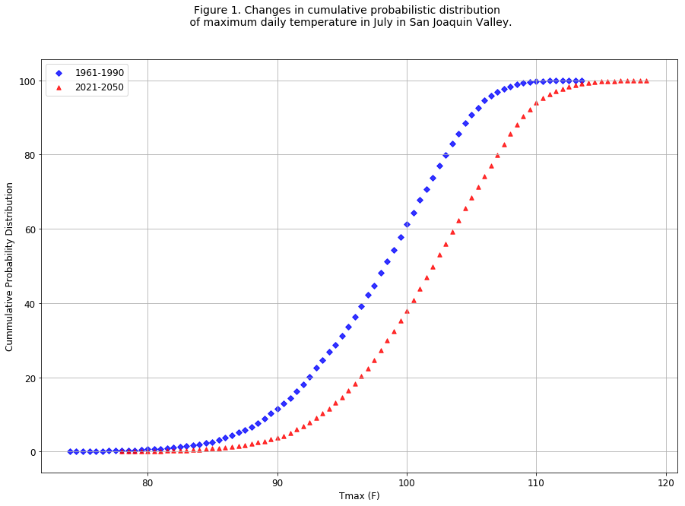

In this graph, blue diamonds represent the cumulative distribution of historical daily tmax and red triangles represent cumulative distribution of projected daily tmax. This shows that how daily tmax is going to be increased in Future yeras. For example, by looking at the x-axis, 100 was around 61st percentile in historical period, but it is less than 40th percentile of projected tmax. Vertical gap in two curves show the percentile difference. Below is a graph with zoomed view in the beginning

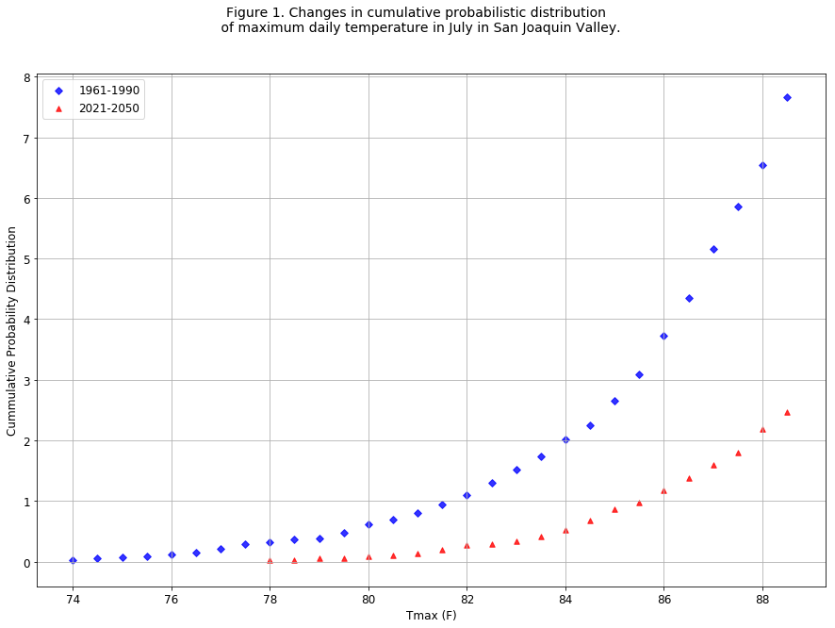

Figure 2. Future Percentile vs Historical percentile tmax in San Joquin valley

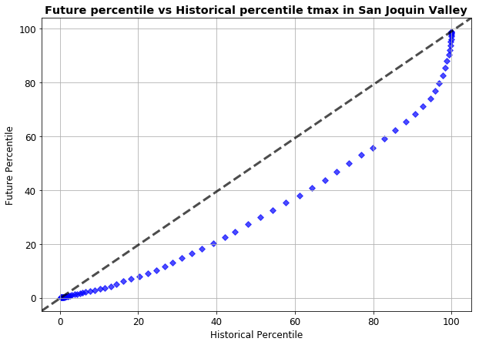

In this graph, we compare the shapes of distribution to find how daily tmax percentiles are different or similar in historical and projected period. If both distributions were similar, the plot would lie on black dashed y = x line. To explain, we will take an example: 40th percentile of historical period is only about 20th percentile of projected years.

Comparing Daily Max Temp of Historical vs Projected Data:

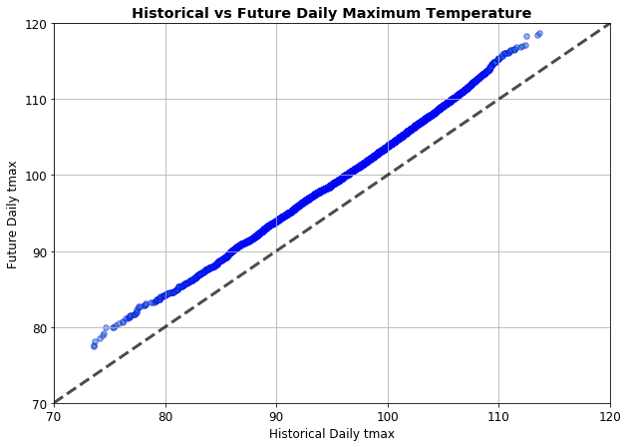

This graph shows that future daily tmax is greater than historical tmax. If historical and projected period had similar values, the blue curve would make a 45 degree and lie on black dashed line in the graph. This graph again emphasizes that temperature is going to be higher in future years. Graph is parallel to the dotted black line, which shoes that the rate of increasing temperature is constant. The average temperature in historical is about 95 degree Fahrenheit. When we trace it y-axis, future, average temperature is about 98 degree Fahrenheit.

**Changes in One in Ten Daily Temp for 30 years:**

Below graph shows the 1 in 10 events in daily t-max for a grid point in San Joaquin Valley. 1 in 10 is equivalent to 90th percentile of events. Graph shows the running 90th percentile of past thirty years for each model. Black curve in the graph is the average of all 10 GCM’s. By looking only at average curve, we can see a large change in 90th percentile as we move from beginning of the century to end of the century. GFDL is the hottest model where CNRM-CM5 is the least hot one.

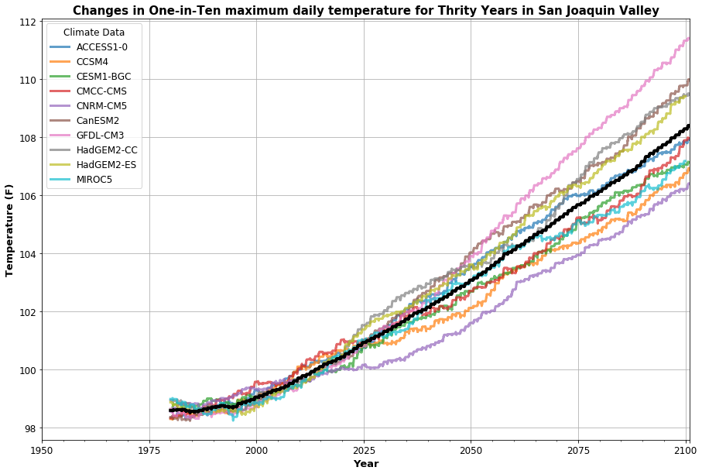

**Probability of Climate Conditions Conductive to Wildfires**

**Introduction:** California fires have been very destructive in recent years. In this analysis, we observe the change in frequency of different events, which might lead to fires. For example, high precipitation in one year lead by very hot temperature in next year. We used the conditions that were originally specified in Balch et al., 2018.

Upper tercile for precipitation from Oct of the prior year to April; top decile of temperature from May to September; bottom decile of precipitation from Sept to December; and, extremely hot Oct to December (OND) period (98th percentile or higher) when the wildfires would tend to occur when vegetation is dry. The terciles, deciles, and percentiles were calculated from the 1961 to 1990 baseline period.

**Variables:** In thisanalysis, we use ten priority models, and scnerios, rcp 8.5 to get daily tmax and daily precipitation. Data was requested from Cal-Adapt API for a loca grid that intersects the the point (-121.8677, 37.9833) in San Joaquin Valley. Historical Data is trimmed to 1961-1990.

**Table 1.** “Probability” of climate conditions conducive to wildfires similar to the ones that occurred late in 2017 in San Joaquin Valley

|  |  |  |  |
| --- | --- | --- | --- |
| **GCM** | **Periods** | **Number of years** | **Probability of occurrence in a year** |
| **Access1-0** | 2020-2050 | 0 | 0.00% |
|  | 2050-2099 | 2 | 4.00% |
| **CCSM4** | 2020-2050 | 0 | 0.00% |
|  | 2050-2099 | 2 | 4.00% |
| **CESM1-BGC** | 2020-2050 | 1 | 3.33% |
|  | 2050-2099 | 1 | 2.00% |
| **CMCC-CMS** | 2020-2050 | 1 | 3.33% |
|  | 2050-2099 | 6 | 12.00% |
| **CNRM-CM5** | 2020-2050 | 3 | 10.00% |
|  | 2050-2099 | 10 | 20.00% |
| **CanESM2** | 2020-2050 | 3 | 10.00% |
|  | 2050-2099 | 2 | 4.00% |
| **GFDL-CM3** | 2020-2050 | 0 | 0.00% |
|  | 2050-2099 | 5 | 10.00% |
| **HadGEM2-CC** | 2020-2050 | 2 | 6.67% |
|  | 2050-2099 | 4 | 8.00% |
| **HadGEM2-ES** | 2020-2050 | 1 | 3.33% |
|  | 2050-2099 | 6 | 12.00% |
| **MIROC5** | 2020-2050 | 0 | 0.00% |
|  | 2050-2099 | 1 | 2.00% |

In this analysis, we do not find any year from historical period to 2020 where the specified conditions were met. Some models predict the occurrence of conditions in 2020-2050. Also note that, unlike 2020-2050, every model predicts some number of years from 2050-2099 which meet the conditions and have higher chances of fires.

To summarize the results, we find the average of number of years in above ten GCMs and calculate the probability according to that.

Table 2. **.** “Probability” of climate conditions conducive to wildfires similar to the ones that occurred late in 2017 in San Joaquin Valley (Year Average from 10GCMs)

|  |  |  |  |
| --- | --- | --- | --- |
| **GCM** | **Periods** | **Number of years** | **Probability of occurrence in a year** |
| Avg of 10 GCM's | 2020-2050 | 1.10 | 3.60% |
| 2050-2099 | 3.9 | 7.80% |

In this table, we calculate the average number of years in ten GCM’s for both 2020-2050 and 2050-2099 times. Then we calculate the probability of occurrence of such conditions. From Table 2, we can see that the such conditions has 7.8% probability to occur which is more than the double of the probability of such occurrences in 2020-2050.